Name: B. Krishna
Id: 2400030120
Exp:5
Sec:09
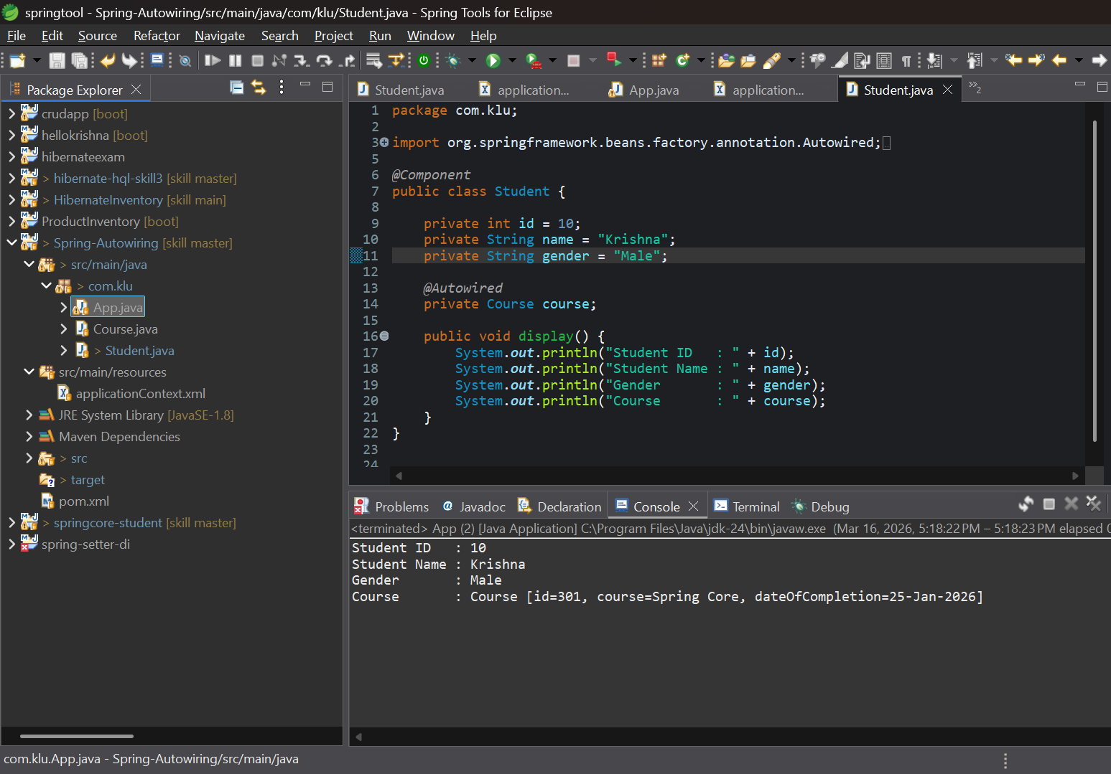

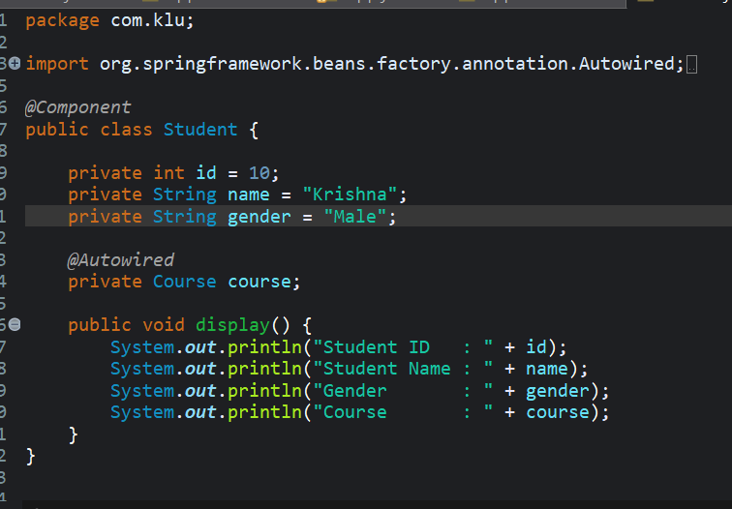

https://github.com/krishna3324/Fsad-Skill.git

